The UC Davis Internship and Career Center (ICC)
Connecting Aggies and Careers

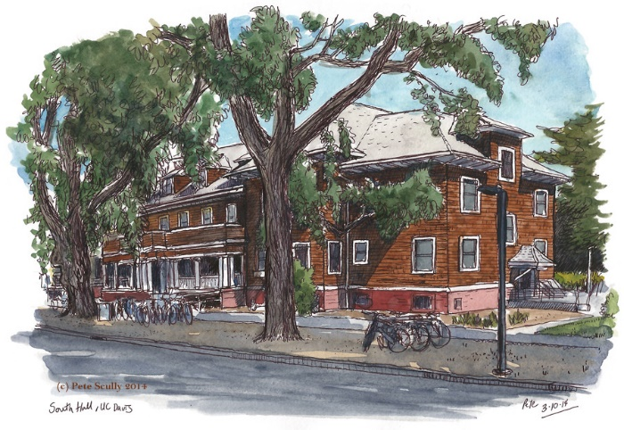

Location and student contact: South Hall, 2nd Floor https://icc.ucdavis.edu/ (530) 752-2855
Faculty contact: Marcie Kirk Holland, Executive Director, makirk@ucdavis.edu (530) 752-0752

ICC Mission
The Internship and Career Center (ICC) provides comprehensive career and professional development services to guide students and recent alumni in making informed career choices and connections. For ICC’s Guiding Principles visit: https://icc.ucdavis.edu/icc-mission

ICC Services for Students
As a full service, centralized career center, the ICC serves all students (undergrad and graduate) from all majors in a wide array of services. ICC services include, but are not limited to;

Fostering Exploration and Connection
The ICC assists students with career exploration including; gaining experience in desired fields via internships as well as part time employment. Examples of services include;
- Support job and internship search, including resources on resume writing and interviewing. Individual and group advising is available Monday – Friday, 10 am – 4 pm.
Drop in or visit https://icc.ucdavis.edu/services/advising to schedule an appointment

- Connect students and employers via Treks, Careers in…….panels, Career Chats, Company Information Sessions, Speed Networking and more!

- UC Davis students participate in internships at rates 10-20% higher than national average. ICC has infrastructure (database of jobs and internships) that makes this possible https://icc.ucdavis.edu/employer/ajl

- Career employment support including: Career Fairs, On-campus Interviews and more!
ICC Services for Faculty and Academic Units

Welcome to UC Davis! The ICC works closely with faculty to help UC Davis students launch their careers. Services the ICC provides include:

Experiential Learning
Best practices and guidance on internships and experiential learning (undergrad and graduate)
- Definitions of experiential learning; internships, research, immersives, co-ops, service learning, etc.
- Recognition of experiences: Transcript Notation, units, micro-credentials, etc.
- Examples of requirements: Duration and hours, length and style of reflection papers, supervision and roles of faculty and site supervisor

Course Support
Consult on ways to incorporate career & professional development into curriculum
- Sample assignments and activities (ex: Career Fair Assignment, Informational Interview assignment, networking activity)
Invite ICC staff to speak in class
Alumni/employer panels that demonstrate application of coursework in careers
Consult on capstone or service learning, including partners (alumni, community or industry)

Research Support
Post research internships in Aggie Job Link https://icc.ucdavis.edu/employer/ajl
Provide guidance on grant applications with professional development requirements
Provide guidance on grant applications with community engagement requirements
Post part-time jobs (work study or not) https://icc.ucdavis.edu/employer/ajl
Professional development for graduate students and post-doctoral fellows

Connections with industry/employers/alumni
Services for employers interested in recruiting UC Davis students and graduates
- Infrastructure including database for job and internship postings https://icc.ucdavis.edu/employer/ajl
Facilitate connections between faculty, staff and employers
- Pre-fair Employer Welcome Receptions
- Company information sessions
- Employer/alumni panelists
- Networking events

Customized Career Courses
ICC has 20 years of experience teaching career courses with academic departments.
Contact us to discuss ideas!

